I2B2 as a caGrid Data Service

# Database

The complete i2b2 + ontomapper database schema:

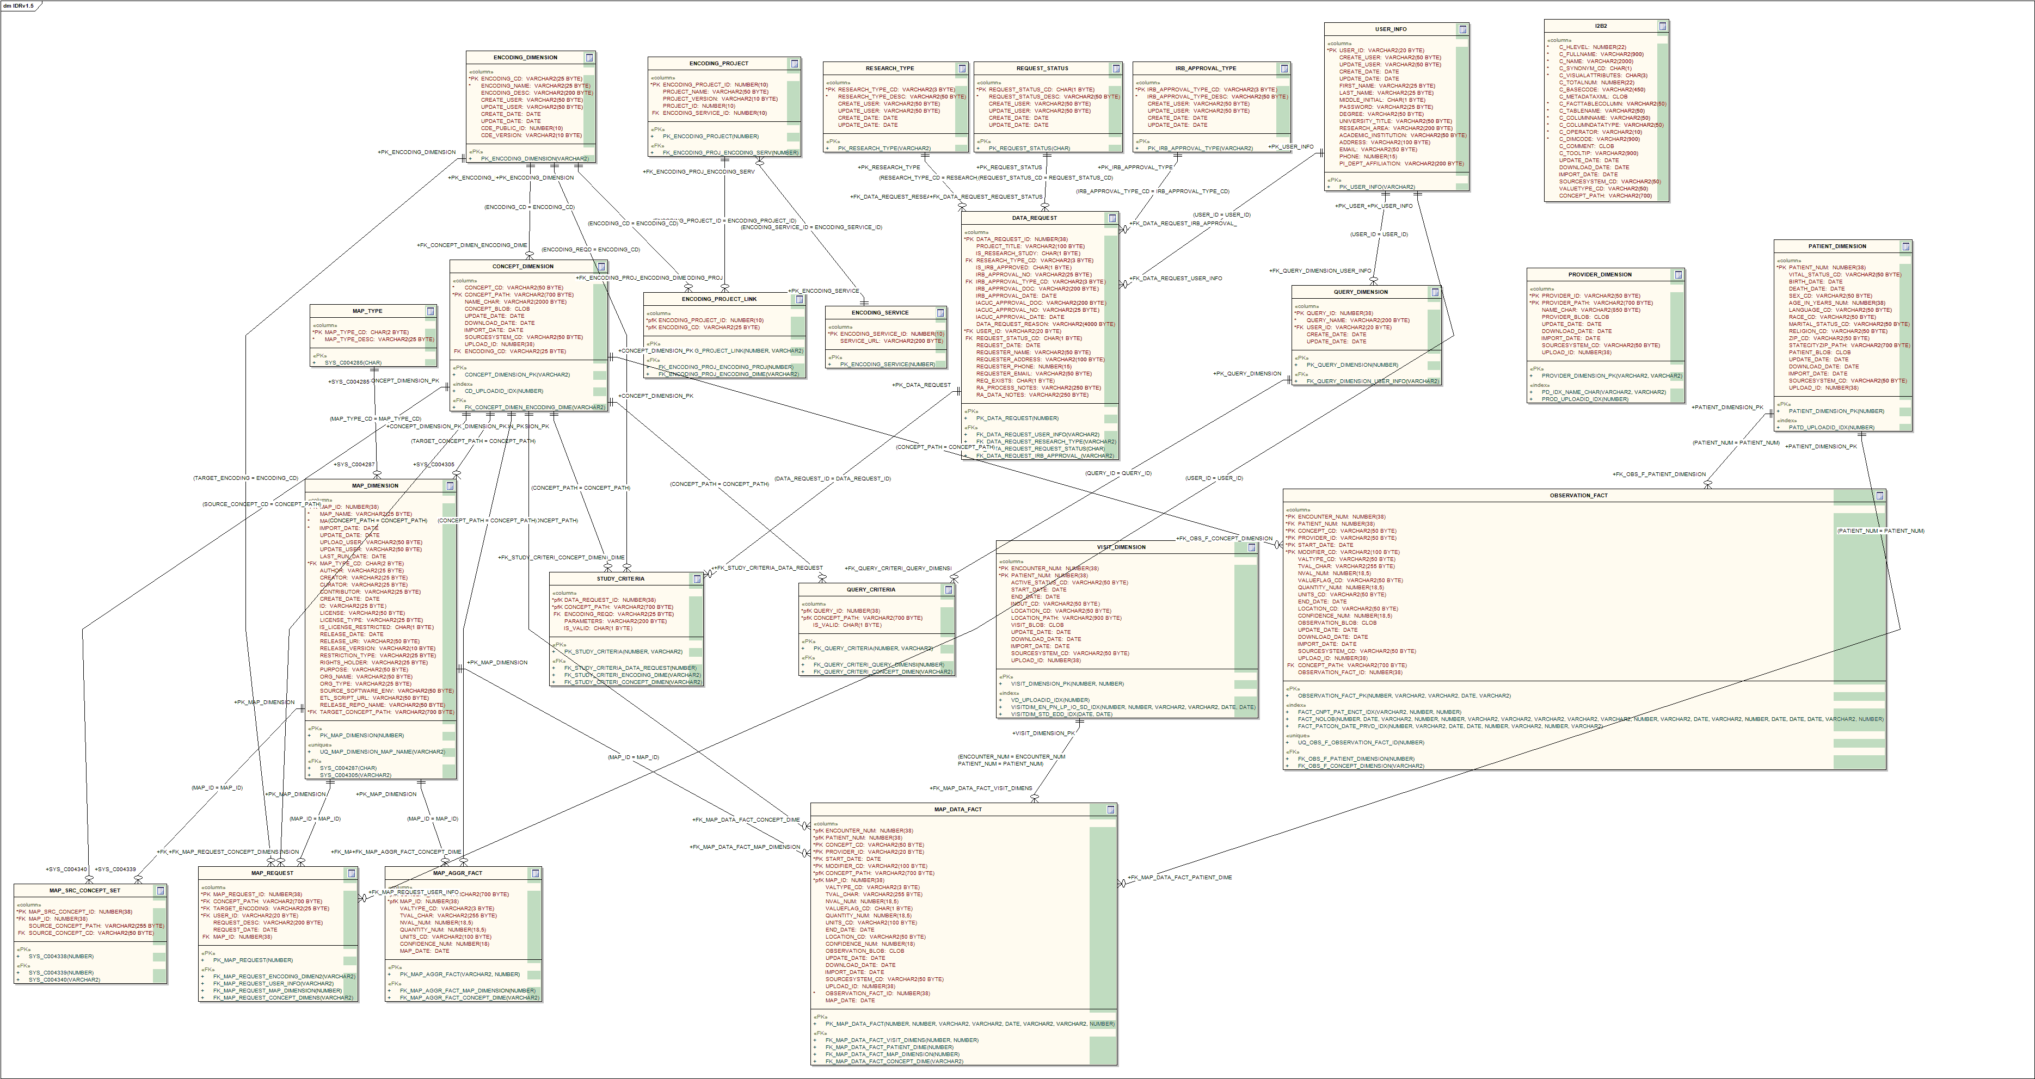

Not all of these tables are relevant to the proposed i2b2 data service model.

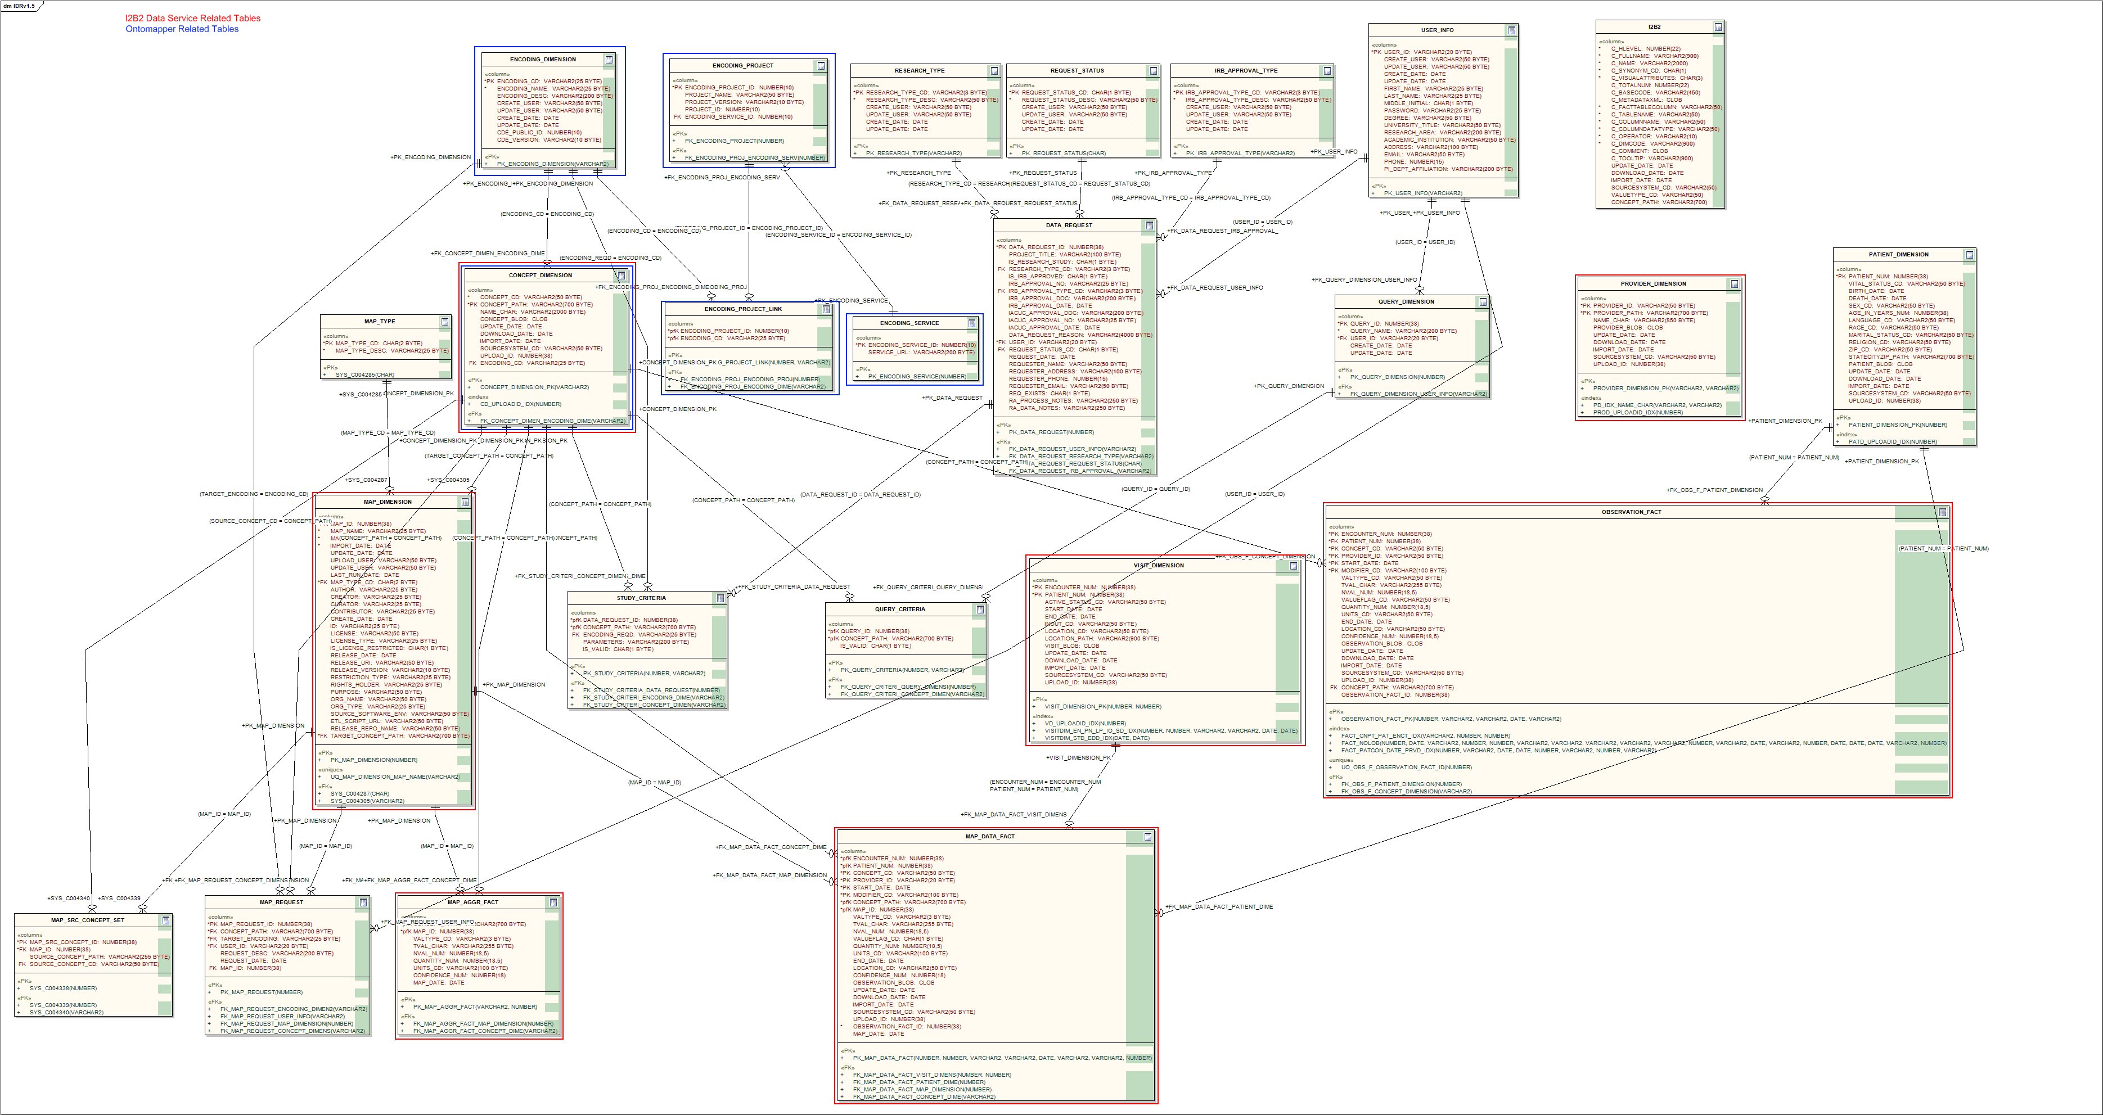

Tables highlighted in red represent tables which pertain to the i2b2 data service domain model and should be exposed via CQL to the grid. Tables in blue pertain to the Ontomapper. The CONCEPT_DIMENSION table is highlighted with both colors, and provides a means of connecting the concept mapping capabilities of the Ontomapper with the clinical data in I2B2.

# Object Model

The I2B2 data service object model: 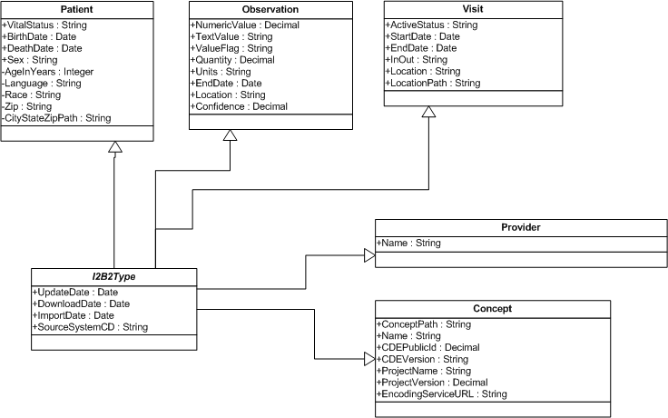

Many of the tables in the i2b2 database schema collapse into single datatypes by way of 1:1 join relationships in the model. For example, the Concept type draws data from the Concept_Dimension, Encoding_Dimension, and Encoding_Service tables to fully describe a concept path, a corresponding CDE, and that CDE’s origin.